Implement program for decomposing time series data into trend and seasonality.

EX:No.7
DATE:07/04/25

AIM:
Write a program to Implement program for decomposing time series data into trend and seasonality.

ALGORITHM:
Step 1: Install required libraries (if not already installed).
Step 2: Import necessary libraries (pandas, numpy, matplotlib).
Step 3: Load air pollution data, parse dates, and set 'date' as the index.
Step 4: Remove duplicate timestamps and fill missing values.
Step 5: Select the 'pollution_today' column.
Step 6: Remove outliers using the IQR method.
Step 7: Ensure daily data frequency.
Step 8: Resample to weekly average (optional, not used in the plot).
Step 9: Create a figure and plot daily pollution levels as a line graph.
Step 10: Set labels, title, and legend for the plot.
Step 11: Show the plot.

CODE:
import numpy as np
import pandas as pd
import matplotlib.pyplot as plt
from statsmodels.tsa.seasonal import seasonal_decompose
df = pd.read_csv(r"C:\Users\exam\Downloads\accident\accident_time_series_1000_rows (1).csv", parse_dates=['Date'], index_col='Date')
time_series = df['Injuries']
decomposition = seasonal_decompose(time_series, model='additive', period=365) # adjust
'period' as per your data frequency

plt.figure(figsize=(14, 10))
plt.subplot(411)
plt.plot(decomposition.observed, label='Observed', color='blue')
plt.legend(loc='upper left')
plt.subplot(412)
plt.plot(decomposition.trend, label='Trend', color='orange')
plt.legend(loc='upper left')
plt.subplot(413)
plt.plot(decomposition.seasonal, label='Seasonality', color='green')
plt.legend(loc='upper left')
plt.subplot(414)
plt.plot(decomposition.resid, label='Residuals', color='red')
plt.legend(loc='upper left')
plt.tight_layout()
plt.show()

OUTPUT:

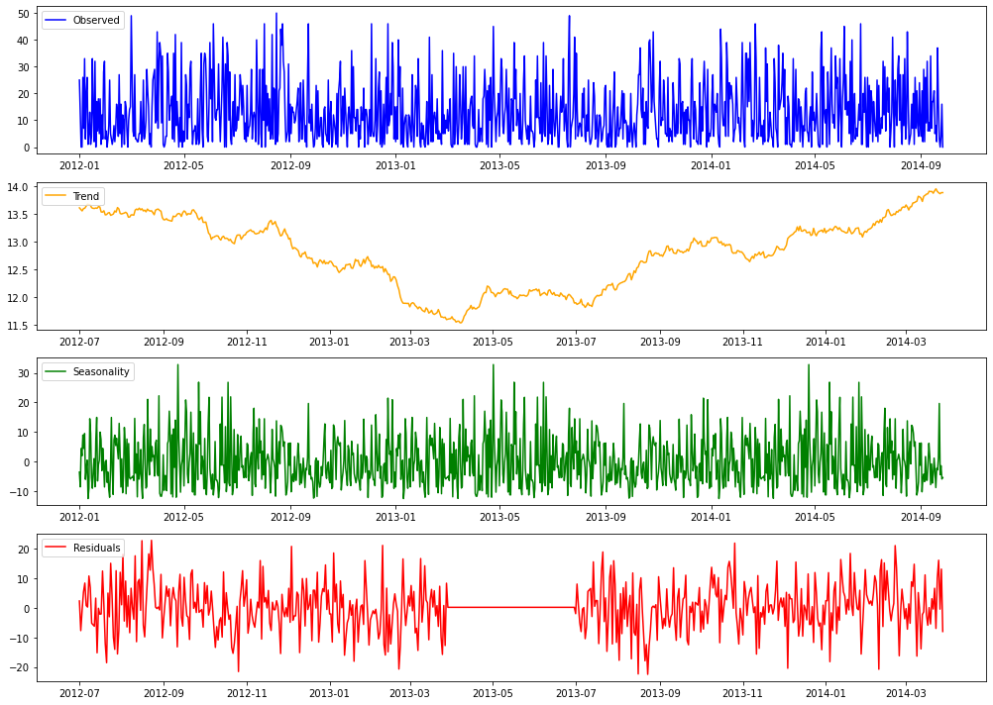

RESULT:

Thus, the program using the time series data implementation has been done successfully.

